General File locations for ASCOM Gemini Telescope Net Install

The install of this driver requires that the ASCOM 5.0a Platform be installed.
This software can be downloaded and installed from:
http://ascom-standards.org/Downloads/Index.htm
The download link is on the right side of the page.

After installing the above package you will need to download and install an update to the above package. This update is in the files section of the ASCOM_Talk group.
http://tech.groups.yahoo.com/group/ASCOM-Talk/files/
.
It will have a name of ASCOM Platform 5.5 Updater, with a description of
Platform 5 Updater Release Candidate.
The current version as the writing of this document is:
ASCOM Platform 5.5 Updater RC3 (v5.5.6.11).exe or similar.

Please download it to a location on your hard drive. I suggest creating a directory
C:\ASCOM Driver Install and putting it there. If using Vista or Win7 please right click on the file and use “Run as administrator” Please accept all the default install values.

If you get any error messages, please use Alt PrtScn (or the snipping tool in Vista and Win7) to copy the error message into a wordpad file and save it as a .rtf file. Please post a message in the user group and send the error message as an ZIPPED attachment to an email to tom@arizonaskys.com
The message will be posted in the files section for you, if there are none like it already posted. Later on we will open up the files section for users to post files.

Next you will need to install the Gemini Driver. You will find this in the files section of this users group. It will be name something like:
GeminiTelescopeInstaller(1.0.x.x).exe The current version as of the writing of this document is GeminiTelescopeInstaller(1.0.20.6) This is subject to change.
Please download it to the same directory as you downloaded the previous file.
Please run the file. If using Vista or Win7 please install as an administrator.
If you receive any error messages, please follow the above procedures.
MENU Selection and locations.

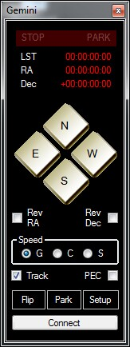

After you have installed the Gemini Driver, there will be a Gemini Icon on your desktop.

If you click this, you will see the will see the Gemini panel displayed to the far left on your p. Also a Gemini Icon is placed in your task bar. What happens is that a icon is put into the taskbar. When you mouse-over this icon, a window will popup showing the loaded Gemini parameters. All these will be null until the Gemini is connected.

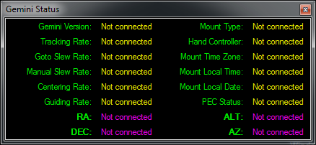
The above menu is displayed on a mouseover of the Gemini Icon in the taskbar. See above. Status will
Be empty until the Gemini is connected.
Setup Menu

Clicking on the SETUP button at the bottom of the Gemini controller menu will bring up the following menus.
- Configure Telescope. -- This is where you will set up the com ports.
- Configure Focuser -- This is the focuser setup menu
- Advanced Gemini Setting – this is where you will set most of the Gemini’s setting
- Observatory Log – displays the log from the Gemini of observing actions.
- Manage Catalogs – where you can manage/add and edit Gemini catalogs
- About Gemini Driver – credit page.
- EXIT – this is where you will terminate the Gemini driver.
NOTE that all these same menus can be selected by right clicking on the Gemini Icon in the Task Bar.

Configure Telescope Menu

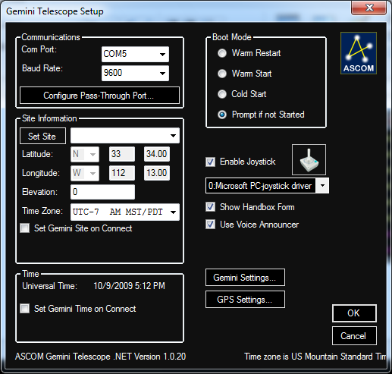
This is the configure telescope menu.

This menu will allow you to setup the Communications port for using the Gemini driver.
There are 3 com ports menus available.
The first is the Gemini port and baud rate. Use this to select which port your Gemini is connected to and it’s baud rate. The driver will autoscan if it does not find the Gemini at this port.
The next is the PASS-Through Port. I will not get into this until later, as these is a very advanced
Option of this driver.

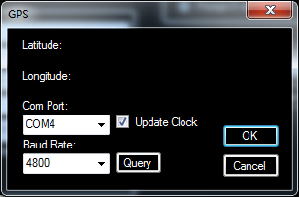
The next is the GPS setting menu. Use this port to select a GPS that you may have installed into one of the serial ports of the Gemini.
You can have it update the PC clock automatically by clicking on the Update Clock check box.
Once a Baud rate and port number is selected, hit the Query for the unit to find and display the latitude and longitude. Note that 4800 baud is default for most GPS units.

